**PROJECT:**

**IMPACT OF COVID-19 ON CONSUMER BEHAVIOUR BASED ON ONLINE SHOPPING**



**Submitted by**

**MARSYA SORFINA BINTE MOHAMMAD**

**H1881069**

**SCHOOL OF BUSINESS**

**Social University of**

**Social Sciences**

**Presented to Singapore University of Social**

**Sciences in partial fulfillment of the**

**Requirements for the**

**Degree of Bachelor of Science**

**In Business Analytics**

**2021**

# Abstract

The aim of this study is to impact knowledge on the effects that Covid-19 has had on consumer behaviour based on online shopping. The consumer behaviour patterns studied were based on a secondary data obtained from [modu.singapore](http://shopee.com/modu.singapore), an e-commerce marketplace. The research, through the use of data analysis methods and techniques, aimed in assessing consumer behaviour patterns based on product purchase, views, likes, buyers’ orders, sales etc. The resulting change in shopping behaviour and what consumers prioritised during the pandemic depending on their interests. By using multiple regression analysis, it was concluded that the pandemic resulted to a hike in the number of online shopping activities. Consumer behaviour changed and in turn affected both traditional and online shopping during the pandemic. The results showed similarities and distinctions in consumer behaviour patterns between different products. Thorough investigation, it shows that this research elaborates more on the variable association theory in alignment to consumer behaviour patterns from other regions during the pandemic. Also, the study offers vital information to other researchers and concerned practitioners like marketers and wholesalers to enact the relevant strategies.

Table of Contents

Abstract 2

Chapter 1: Introduction 3

1.1: Problem Statement 8

1.2: Research Objectives 9

1.3: Scope of the Study 9

1.4: Justification and Significance of The Study 9

Chapter 2: Literature Review 10

2.0: Introduction 10

2.1. Consumers’ behaviour during pandemic situation 12

2.2. Fear appeal and the change in consumer behaviour 16

2.3. Generation differences and shopping behaviour 18

Chapter 3: Methodology 22

3.1: Introduction 22

3.2: Analysis methods and Techniques 23

3.3: Target Population 25

3.4: Data Collection Process and Procedures 26

3.5: Sampling Design 26

Chapter 4: Data Analysis and Modelling 27

4.1: Introduction 27

4.2: Descriptive Statistics 28

4.3: Inferential Statistics 32

4.4: Model Building 36

4.5: Results Discussion 38

4.6: Conclusion and Recommendation 39

4.7: Study Limitations 40

References 41

Appendix 43

# Chapter 1: Introduction

The outbreak of Covid-19 (Coronavirus) was first experienced in China, however the virus largely continued to spread to other parts of the world. Covid -19 brought into standstill a lot of activities as the virus was termed deadly and contraction of the Covid-19 was very high. To curtail the spread of Covid-19 that seemed to increase rapidly and putting the lives of individuals in danger, the World Health Organization (WHO) encouraged countries globally to adhere to Covid-19 protocols which were expected to lower the spread of the pandemic. For this reason, therefore, many countries adopted the Covid-19 protocols. For instance, WHO encouraged countries on wearing masks, regular washing of hands and sanitising as well, keeping social distance, avoiding public gathering among others. Due to observation of social distancing even in working organisations, many companies ended up firing quite a large number of their staffs and workers. Restrictions of movements from one country to another was as well instilled as it largely assisted against more spread of the Covid-19 pandemic. Many schools worldwide were closed down and online learning was adopted especially in those countries that had enough facilities to perform online learning. Closure of learning institutions, eateries, bars and restaurants left quite a large number of people unemployed. The livelihoods of these families thus suffered hardships of meeting their daily needs.

In fact, the containment measures of Covid-19 pandemic negatively impacted economies globally to a large extent, markets, and businesses. The breakout of the Covid-19 pandemic brought transformations in several ways including the way people worked, communicated and the way they did their shopping. The spread of the Covid-19 demonstrated transformations in the level of spending on consumers. The containment measures put forth by the WHO were forced to shift to online shopping e-payment, and even home deliveries (Pantano et al., 2020). Verma and Gustafsson (2020) mentioned that there is a call for both the managers and marketers’ retailers to keep in charge the changes in the behaviour of consumer online shopping for the purposes of understanding the changes in plans that they need to adopt. The sale of daily necessities was on rise during the onset of Covid-19 pandemic. The Covid-19 pandemic however, brought large impact on the consumer behaviour as it led many consumers worldwide to rapidly transform their shopping behaviours. This happened due to measures that were put in place by the WHO for the purposes of curtailing rapid contraction of the Covid-19 to ensure safety and health of individuals. During the onset of first phase of the Covid-19 pandemic, countries and regions were forced to close restaurants to lessen the spread of the Covid-19. The observations of the Covid-19 measures including the restriction of movements, across countries and regions, observation of social distances and others greatly impacted the manner of the consumer buying and shopping.

According to Acosta (2020), some consumers ensured that they had enough groceries in their homes due to disruption issues of short supply. Consumers did not only stockpile groceries but also other basic commodities including cleaning products, toilet papers, enough water, among others. They conducted hoarding for the purposes of managing uncertainty of future supply of goods. The manner of stockpiling had to happen due to fear of the consumers getting more exposed outside which would increase the risk of contracting Covid-19.

Many consumers preferred purchasing commodities online and this trend continued to rise due to the pandemic. With respect to a survey done at the onset of the Covid-19 pandemic, only one out of three consumers had experienced the impact of Covid-19 on their consuming behaviour. However, this was seen to gradually improve to point where nine out of ten consumer behaviour were being impacted by the Covid-19. The consumer behaviour changes based on the Covid-19 pandemic varied differently among individuals, as this depended on the geographies, cultures etc among individuals. The pandemic thus resulted to greater alteration of individuals purchasing habits. Basic needs including food, water, hygiene, and cleaning products, sanitisers, and protective devices that is masks, have become consumers prime concern. The tendency of buying more basic goods was on the rise as the pandemic continued to spread, transforming the patterns of consumption simply by reducing the sales of other less important commodities such as clothes and luxury items. During the onset of pandemic in Italy, the consumer manner of consumption was observed to change as individuals focused on buying essentials commodities more, so those goods related to the prevention of the Covid-19 including sanitisers and protective masks.

Not only in Italy where consumers preferences focused on basic essential commodities but also in India, where the same case was experienced during their first phase of the pandemic. Consumers preferred to purchase essential goods more than the non-essential goods. Due to lockdown and social distancing, many consumers globally shifted to online shopping. For this reason, therefore, a lot of businesses were forced to find ways of selling their products online and delivering the goods to the consumers household. Online shopping therefore brought a great transformation on how the markets operated. As a result of the lockdowns across countries and regions, consumers adopted the method of ordering commodities online and the products were later delivered right to their doorstep. The manner of doing online shopping was termed safe, easy, and effective because it reduced the contraction of the Covid-19. Despite several consumers preferring online shopping, several companies in the less developed countries did not take up the path of online shopping as they argued that they did not possess enough facilities to adopt online shopping. In addition, they found it complex to invest in online shopping since they had not enough growth that could facilitate safe and effective online shopping. According to Ali (2016), some consumers globally feared doing online shopping because of several factors including economic uncertainty, insecurity, lack of transparency among others.

During the pandemic, e-commerce has been key principle and thus retailers had to put much more effort in promoting, building, and upgrading the online stores. Those retailers who had not managed to put up their commodities online before the onset of the pandemic were forced to find possible means of selling their products online. There were also other sellers that went to an extra mile of offering discounts on their productions and initiating promotions on social media platforms. The embracement of e-commerce in some regions worldwide faced quite several problems including in availability of technology, unreliable telecommunications, unstable government rules and regulations, electronic payment, failure of trust among others. According to Saouri et al. (2019), understanding the consumer behaviour and offering the appropriate services in the shortest time possible is fundamental. This is because at times consumers attempt to buy a product online, but they end up failing to complete the whole process. Some are unable to place the selected product in the cart, others are unable to select the product, while others face difficulties while paying and thus for this reason, they end up leaving the website without purchasing anything. Obstacles relating to the pandemic thus added relevance in paying close attention to consumer satisfaction during online shopping. The consumers main concern relating to e-commerce is privacy, security, and the quality (Pratminingsh et al., 2013). Proper adapting of digitalisation would improve the e-commerce sector thus curtailing the fear in consumers.

The issue of using the credit cards while carrying out daily transactions has been adopted in some regions worldwide while in other regions the utilisation of credit cards has remained low. For instance, in the case of Iraq, use of credit cards in Iraq remained low as individuals preferred using cash while carrying out their daily transactions. The reason behind minimal usage of credit cards in carrying out transactions was the incapability of financial institutions in providing required services in issuance of the credit cards due to lack of the appropriate infrastructure. The context of Covid-19 pandemic remains unsettled despite countries globally lifting the containment measure as the Covid-19 vaccines are available currently. Online purchasing remains to be inherent to many business operators since many consumers prefer to shop online even after the lifting of the containment measures. Development of the internet infrastructure has ushered in new era of growth of business via online and e- commerce.

## 1.1: Problem Statement

Covid-19 pandemic has brought disruption to the lives of individuals globally, from how individuals carry out their daily activities, their socialisation, and the manner of consumer shopping. The consumer behaviour greatly transformed in the light of the pandemic. The trend in consumer behaviour has been fluctuating since the onset of the first phase of the Covid-19 pandemic. Despite these fluctuations, the impact of Covid-19 on consumer behaviour has remained high. The shift to online shopping has been on the rise due to continued movement restrictions, and social distancing across countries globally. Recently, with the overall level of the Covid-19 pandemic going down, some countries and regions has removed the restriction of movements. Easing the Covid-19 pandemic restrictions across countries has posed the question of whether the consumer will continue to shop online. This study ought to determine the impact of Covid-19 pandemic on consumer behaviour based on online shopping. Further, the study seeks to find out other consumer behaviours that are coming out in response to Covid-19 pandemic.

## 1.2: Research Objectives

The study aims at investigating impact of Covid-19 on consumer behaviour based on online shopping.

## 1.3: Scope of the Study

This study focused on the impact of Covid-19 on consumer behaviour based on online shopping for the period extending from the onset of the first phase of Covid-19 pandemic.

## 1.4: Justification and Significance of The Study

This study is relevant to researchers, marketers, retailers, consumers, businessmen, and policymakers in understanding the linkage between covid 19 and consumer behaviour based on online shopping. This study is important to policymakers as it will enable them in drawing appropriate approach in response to public demand thus contributing to the growth of the economies globally. Also, this study is relevant to consumers as it will help them know the behaviour of other customers based on online shopping. It is crucial to researchers to clear the doubt as many studies on impact of Covid-19 on consumer behaviour remains inconclusive. Literature review reveals mixture of findings based on impact of Covid-19 pandemic on consumer behaviour based on online shopping. This study therefore examines the impact of Covid-19 on consumer behaviour based on online shopping and thus filling the existing knowledge gap.

# Chapter 2: Literature Review

## 2.0: Introduction

Organisations across the world face uncertainties and issues daily (Eisenhardt Melissa and Scott 2016; Ferraro et al. 2015). As a result, the inefficiencies and hazards that come with it have a direct effect on the local economy (Jarus, 2020). Covid-19's consequences have been unprecedented, defying even the most optimistic predictions (Carlsson-Szlezak Martin and Paul, 2020). According to Stanciu and Stryker, tens of thousands of outbreaks (including smallpox, pneumonic plague, Spanish flu, human immunodeficiency viruses, acute respiratory syndrome have transpired across history of mankind. As has been observed in many cases, these viruses had a directly negative effect on employment and industries. Covid-19 has already caused damage on the global economy, leading stock markets to shut, company headquarters to shut, small businesses to close, and key social occasions to be cancelled in various nations. Decreased spending and investment have impacted a slew of other industries that rely on strong economies (Ozili and Arun, 2020). The outbreak has had a negative influence on products in China across a wide range of market sectors (Chen Wenlan and Qiang, 2020). In the United Kingdom, economic consumption has switched primarily to necessities such as foodstuffs (Chronopoulos, Marcel and John, 2020). In Denmark, purchasing of goods and services has dropped by 27% (Andersen et al., 2020), with more of the money that goes towards personal safety items (Addo et al., 2020). In Romania, individuals' work activities and economic tastes have changed, forcing firms to adapt and reconsider their strategies.

As a result, shopping online has increased, and consumers are exercising prudence when shopping at home alone. As a result of these changes, including the most vehement competitors of online purchasing have had to shift their minds and adopt (Stanciu et al., 2020). Eateries and retail businesses have been particularly heavily hit (Baker et al., 2020). Expensive and high retailers are also suffering from a lack of value-oriented products and promotions (Roggeveen and Sethuraman, 2020). Several flexible businesses, on the other hand, have quickly adapted and are displaying new signs of development at this moment (Knowles et al., 2020). Numerous economic repercussions of the virus have been witnessed in the food business due to pauses in the food production chain in multiple parts of the universe, frantic purchasing, and other pandemic-related factors (Nicola et al., 2020). Skills shortages and health issues are two major consequences (Hobbs, 2020). Access to food in Canada has been unaffected by the epidemic, although the source of supply has shifted from catering services to retail channels (Richards and Rickard, 2020). Nevertheless, clients in Indonesia have increased their risk-mitigation measures in terms of food suppliers, with a particular focus on commodities imported from China (Widayat and Arifin, 2020). Clients in India have become suspicious of restaurants, preferring to buy necessities via the internet (Rao and Moorthy, 2020). A variety of factors play a role in consumption, particularly location and timing. When it comes to consumer behaviour, habits have an impact on what people buy, when they buy it, and where they buy it (Sheth, 2020b). As a consequence of the outbreak, not only have consumer habits altered, but so have retail operations (Hartmann and Lussier, 2020).

Serious institutional changes have been accelerated around the world because of the pandemic, specifically in high - resolution digital revolutions (Kim, 2020). Unfortunately, the disease is a very real concern that has spread among employees in all the companies that have already been affected by client behaviour changes (Elrhim and Elsayed, 2020). Many production lines have been forced to take strict preventive steps because of this conjoined risk, which has hurt Chinese enterprises in particular (Hasanat et al., 2020). Consumer preferences for books in Vietnam has migrated to online commerce, according to Nguyen et al. (2020). By evaluating billions of credit-card transactions, a study in France explored customer expenses mobility and online–offline modification reactions during the deadly virus, finding that the digitally option loosened the pandemic's cruelest implications on household consumption while mirroring the perseverance of a thriving economy (Bounie, Youssouf and John, 2020).

## 2.1. Consumers’ behaviour during pandemic situation

Customer expectations of goods shortage may have a great effect on the buying choices (Hamilton et al., 2019; Laato et al., 2020; Pantano et al., 2020). Far since the eruption of Covid-19 plague in early 2020, buyers have started keeping stock, which is a noticeable change from their normal purchasing habit. The constrained availability of shop facilities, along with buyers' growing health matters, has led in an abrupt boom in interest for substitute distribution networks. Customers' favorite purchasing channel is being influenced by unanticipated laws that cause social division. For instance, whereas internet food shopping has increased progressively but slightly over the past century (Harris et al., 2017), it exploded during the pandemic (Pantano et al., 2020). In addition to internet purchasing, other delivery methods that do not involve direct interactions may become more popular (Amazon, 2020; Kirk and Rifkin, 2020). Measures to curb the pandemic and the desire to vacant from home just in the direst of circumstances have resulted in a high portion of appointments for last-user deliveries, as well as a ten-percentage-point increase in this business.

The number of Czechs who purchase online has risen from 38 percent to 53 percent this year (CZSO, 2020). Clients have studied their buying habits, according to Pantano et al. (2020), and recognising gains from lately undiscovered services. Some users, for example, are moving to e-commerce shopping because of the privacy and safety of house delivery, store picking, and smart key payments. Furthermore, these authors discovered that unexpected government policies mandating social isolation are experiencing a substantial effect on customers previously liked purchasing platforms. The government braced for containment by closing schools, cafés, some stores, and social utilities, according to Laato et al. (2020), which may have induced fears of coming disturbances and spurred behaviour patterns in people. It's also realistic to anticipate that customers' shopping habits will change over time in this scenario. Sheth (2020) claims, for example, that consumer behaviour is regulated or disrupted by four critical circumstances. Based on culture situation (e.g., shifting in the working area and interacting with people surrounding and friends), the creation of additional sophisticated innovations (such as internet purchases and dissemination), the usage of different regulations (including the Covid-19 epidemic legislation) on usage behaviour, and the list coherent background are all factors to consider (the establishment of the world Covid-19 outbreak). There are several factors that influences new buying preferences. They include government regulation, both at the European Union and national levels in each country (e.g., Council of Europe, 2020a), contemporary invention and its improvement (cf. DESI, 2020), and shifting regional areas (e.g., Council of Europe, 2020).

All customer perception and expenditure are time and region based (Sheth, 2020). According to Kirk and Rifkin (2020), periods of the outbreak mostly result in significant sociological change, and they encourage paying close attentiveness to customer behaviour in all these three rounds: reacting, adopting, understanding behaviours, and considerably longer adaptation. In spring 2020, Accenture (2020) and McKinsey (2020) conducted earlier research. According to Accenture (2020), customers are highly bothered on the repercussions of the virus, both in terms of healthcare and finances. The outcomes of the survey found that people concentrated their purchases on the highly human basic wants, that they bought more thoughtfully, that they shopped locally, and that they welcomed e-commerce purchasing. Individuals have been using information and communication technology (ICT) to socialise, study, and play in order to overcome isolation, and they will most certainly continue to do so in the future. As they begin to cope with the virus threat, people are responding drastically to brand initiatives. Organisations with a significant environmentally accountable branding (Kirk and Rifkin, 2020; He and Harris, 2020) are likely to face excessive customer reaction if they are regarded as breaking their promotional pledges during the breakout (Kirk and Rifkin, 2020; He and Harris, 2020). In a previous Edelman Loyalty Ometer unique poll (2020) of 11,000 countrywide consumers, for example, 75 percent of customers said how organisations react upon the virus will have a great effect on long-term purchase preference.

This evaluation study was done at the time of first round of pandemic in May. As per the statistics, 25 percent of individuals have willingly walked away from a firm because of what they term to be an insufficient crisis action. People all over the world move their buying loyalties in diverse ways, according to the McKinsey (2020) poll. Merchants and municipal agencies are aware that their responses to the crisis would have a big impact on the industry, but due to the limited period, they are trying to respond. People who stopped buying the labels during the first phase of the pandemic crisis, according to Pantano et al. (2020), may wish to buy them again at the time the risk has receded if they perceive the firms or merchants were sympathetic and did everything they could to help. The underlying condition has had a countrywide impact on business. Businesses have been suffering increased opposition from other online retailers; the viral outbreak will happen to be the tipping point, and they will either shift away from the business or shut a huge number of store locations, prohibiting clients from resuming to their prior purchasing preference.

## 2.2. Fear appeal and the change in consumer behaviour

Most cognitive (planned) and emotional (impulsive) shopping carts are driven by hedonistic (psychological) and economical (practical) urges, according to current studies (Ahmed et al., 2020; Leverin and Liljander, 2006). Couple of research indicated that as a result of the pandemic, compulsive purchase has risen considerably across all countries. As a result, the Fear Appeal theory was employed in this investigation. According to Ahmed et al. (2020), this is a nearly obsolete hypothesis. The Fear Appeal idea has not been widely used in academic study in recent years. It's employed in healthcare insurance, and product safety measures, among other things, in marketing and advertising efforts. According to Addo et al. (2020) and Wegmann et al. (2020), fear originated as a strategy to defend life-threatening illnesses. According to Lai et al. (2016), dread appeal is comprised up of three major concepts: recognised effectiveness, risk, and horror. Dread appeal can be separated into two categories, according to Wegmann et al. (2017): fear management and danger control, with fear control concentrating on sentiments and emotions related to risk and danger control directing consumers' responding action to evade it (Accenture, 2020; Addo et al., 2020). According to Addo et al. (2020), fear dominance drives behavioural responses to deal with or evade obstacles, whereas risk control directs behavioural reactions to deal with or evade collisions.

Fear Appeal appears to be a crucial mediating element during consumers' purchasing behaviour, according to several research. Levin et al. (2021) found an increased association between the age and infected mortality degree for the virus in their meta-analysis. Covid-19 and its repercussions have been linked to anxieties, concerns, and tension, according to studies, and has become one of the key variables affecting people's health and well-being around the world (Ahorsu et al., 2020; Reznik et al., 2020). Moreover, some research suggests that the prevalence of fear responses in the individuals is linked to age (Sljivo et al., 2020; Chen, 2020). In general, buying judgments and consumption habits are the result of weighing the benefits and drawbacks of various products, as well as the emotive and sensitive features of those things. Merchandise that are thought to conquer a certain risk or danger, instilling dread, and may be effective at reducing danger assessments, attract more transactions. This study, like Addo et al. (2021), is found on the preceding premise and forecasts that, in the aftermath of Covid-19’s further expansion, fear recognizant will have a significant association with the buying of specific products. Based on the previous literature, the following study hypotheses about the Fear Appeal theory were established:

**H1.** Client shopping choice is motivated by their level of health fears during the COVID-19 pandemic outbreak.

**H2.** During the COVID-19 outbreak crisis, the degree of economical fear effects client purchase behaviour. The study focuses on a purchase evaluation of important things, such as purchasing based on utilitarianism (requirement) and hedonistic stimuli (Wegmann et al., 2017; Ahmed et al., 2020). There are several aspects that influence how people buy things, but customer requirements might be regarded the initial process in the buying steps (Solomon, 2002; Maslow, 1970). The preceding physiological wants, according to Maslow's needs hierarchy, usually develops in a moment of dread, suffering, or deprivation, such as the Covid-19 pandemic. Consumers are motivated to act, including purchasing activity, by some basic human needs (Seeley, 1992). The fundamental humankind necessities brought in a massive surge in consumption, having many establishments diminishing out of critical items and a lot of non-important items being overlooked in the time of epidemic purchasing behaviour (Deloitte, 2020; Accenture, 2020). The fear of COVID-19 and total confinement has experienced a significant effect on residents in several countries in autumn 2020. The Republic of Czech was one of the nations with an undesirable growth in virus per thousand persons at the start of the second surge in Europe. Individuals were prone to impulse purchases because of bad content in the mainstream internet and media (especially social media), peer word, and studying their neighbors' and peers' purchasing habits. We believe that Covid-19 has resulted in increased employment and health difficulties, and lack of facilities to meet fundamental humankind requirements. As a result, according to the literature and the incident in the chosen nations, the following proposition is formulated:

**H3.** During the Covid-19 period, consumers are a lot more concerned with the human wants than with self-fulfillment.

## 2.3. Generation differences and shopping behaviour

As per Liu et al. (2017), the webpage excellence, which acts as a first perception for consumers thinking about making a purchase online, is the most effective central aspect impacting customers' online shopping behaviour. Wang et al. (2005) conducted an empirical study on digital purchases and revealed that the accessibility of online had a significant effect on consumers' choice to buy online. Product factors are features that are directly related to the purpose. When it comes to making a transaction, product variables are extremely important. Product quality, according to Smith and Wright (2004), is the extent to which a corporation offers products that meet customers' expectations.

Customers that shop online have accessibility to item details, as well as other options. In Singapore, varied product characteristics, authenticity, efficiency, and endurance of services will substantially impact customer's choice among retail outlets and online purchasing, according to Phau and Poon (2000). Again, according to Al-Azzam (2014), product quality and durability, as well as numerous distinctive characteristics, affect customer behaviour while purchasing online. Although numerous aspects influence client purchase decisions, quality of products, effectiveness, and longevity are the most essential (Al-Maghrabi et al., 2011). Product quality, according to Rusmiati et al. (2020), has a significant impact on customer purchasing decisions and contentment. According to Andreti et al. (2013)'s research in Indonesia, the majority of customers frequent stores and make purchases depending on the quality of products and services provided by these businesses. As a result, product quality and functionality are one of the most important factors influencing customer online shopping behaviour. The following hypothesis (H1) for the current investigation is based on the discussion:

**H1:** Product quality has a substantial beneficial influence on customers' online purchasing habit.

Endurance refers to a physical entity's ability to remain operational and perform well over the extent of its expected lifespan without requiring extensive repair or replacement. Creating more durable items is a vital technique for the sustainable society, according to Hossain et al. (2018), because it preserves resources and minimizes the amount of garbage produced at the company's end of life. Robust item designs, on the other hand, must include an evaluation and validation of the item's endurance for both the company and its consumers. As a result, product resilience is one of the most important factors influencing customer online purchase behaviour. The following hypothesis (H2) for the current investigation is based on the discussion:

**H2:** Product durability has a substantial beneficial impact on customers' online shopping habits.

Consumer fulfillment is influenced by two key factors: reliability and consistency. Reliability aids in the development of dependability and devotion for any sort of service company everywhere in the world. It refers to a company's capacity to provide expected quality service and deal with customer issues and criticism. Another important component in consumers' online buying behaviour and e-loyalty is confidence, as described by Gommans et al. (2001). Security and trust are intricately connected. As customers cannot see the products in person when purchasing, they are unable to look into the eyes of salesperson, but businesses must build customer satisfaction to avoid doubt. Ltifi and Gharbi (2012), on the other hand, argue that loyalty implies a strong link between the brand and the customer. The emotional tie that links clients' purchasing, and consumption behaviours demonstrates this deep connection. As a result, one of the primary indications that influences customer online shopping habits is merchandise trust and trustworthiness. The following hypothesis (H3) for the current investigation is based on the debate.

**H3:** Customers' online shopping behaviour is significantly influenced by product trust and confidence.

A fair pricing is an appropriate charge for a service or product that is determined upon by both parties in terms of agreed-upon conditions, pledged competence, and efficiency punctuality. People buy online and are pleased, according to Liu et al. (2008), when the company charges reasonably. Customers want to purchase things again when they find a fair price, according to a study conducted by Chu and Lu (2007) in Taiwan. A fair price is the amount of money that can be expected to be paid for goods and services. According to Kotler (2012), pricing refers to the amount of payment required for a product or service, as well as some of the qualities that consumers compensation in swap for the services they obtain. However, according to business literature, pricing fairness is important when it comes to customer happiness (Herrmann et al., 2007). Consumers perceive price as an indicative of a package's merits, according to Rehman et al. (2017). Wang et al. (2005) define cost as the amount of money (plus a few products) needed to obtain a mixture

# Chapter 3: Methodology

## 3.1: Introduction

Methodology refers to a detailed process and procedure applied to achieve something. Not only in research study, but methodologies are also applied in various areas involving a series of events to be undertaken. For instance, in system and software development, hospitality, health and engineering for instance, has different processes which requires different methodological approach. A research methodology on the other hand is a process that have a detailed process on how to identify, select, process, and analyse information about a topic. Various research methodology exists in the context of research. They include qualitative, quantitative, and mixed methodologies. A qualitative mythology is applied in the context where the data at hand is immeasurable in nature. Furthermore, the qualitative methodology deals with the quality aspect of the data where question such as why, how, when are answered. The quantitative methodology deals with measurable data and aims to answer questions such as how much, how long and what is the difference. Mixed methodology is applied in the context where the data used by the researcher is a mixture of measurable and immeasurable datasets. This cased applied both the qualitative and quantitative methodology. Research methods applied which consists of research study includes, interviews, surveys, experiments, questionnaires, case studies, observations etc. Understanding the impact of Covid-19 on consumer behaviour requires a detailed approach on how to structure and approach the study. Based on the objectives of the study, a quantitative data is required. This would enhance the investigation of association among variables before and after Covid-19. Additionally, establishing the difference and association ascertained is statistically significant is of importance. This acts as a confirmation that the results obtained from the analysis process did not just happen due to chance.

## 3.2: Analysis methods and Techniques

Quantitative methodology was applied to investigate the impact of Covid-19 on consumer behaviour with reference to online shopping. Similar to other aspect of living, shopping was disrupted when Covid-19 hit the world. Physical shopping was replaced by online shopping and millions of transactions took place during this period. To critically understand the impact brought about during the pandemic, investigating online shopping data would be more insightful since majority of people shopped online during the period. A dataset on product reviews, sales and products performance was obtained from a personal online store ([modu.singapore](http://shopee.com/modu.singapore)) from Shopee Singapore, an e-commerce marketplace that also became increasingly popular during the pandemic. A glimpse of the data suggested that the data would require quantitative methods from proper and comprehensive analysis. Since the data was obtained from a second-hand source, it can be regarded as a secondary data. Mining insightful information from this data required application of data analysis methods and techniques, the methods applied included, the descriptive statistical, construction of charts, figures and tables, correlation analysis to establish such association among data variables, inferential statistics, and statistical models. Inferential statistics is a branch of statistics that is concerned with making decisions based on a sample dataset. Since the data obtained was a representative sample, applying inferential statistical was reasonable. Data analysis process requires application of more that 2 variables in a dataset since when analysis and visualisation is made with a few dimension trends and relationship might be difficult to identify. Upon adding more dimension on visualisation and analysis, trends and association began to be vivid and open.

The three-dataset obtained contain different information that is very important in understanding the research objectives. The multiple liner regression model was applied to establish the impact of Covid-19 in consumer behaviour. Line plots was used to show the trends of shopping behaviour over time. Scatterplot established liner relationship between the variables in the data. SPSS was used in data analysis process as it analyses the data collected from a statistical point of view. This aided in analysing why people prefer online shopping from physical shopping. Similarly, how Covid-19 has led to an increase in online consumers. Additionally, the research analysed how some businesses have found it difficult to penetrate the market after the Covid-19 outbreak. This is because their products or services are unavailable on online platforms.

The process of analysing the data began with the data cleaning and variable transformation. This helps to remove any errors and inconsistencies in the data. Terraforming the variables also aids in new variable generation that might be insightful in the prices of data analysis. After cleaning the data, descriptive statistics was conducted to help the research have an in-depth understanding of the data and variables distributing. The viability of statistical methods and techniques applied depends on the distribution of the data. If most of the variables in the data are not normally distributed, normalising the variables is required, if not possible, then it calls for the application of non-parametric statistics methods. Normality tests were conducted to certify existence of normality in the data that is a primary assumption of regression modelling. Finally, the results obtained from the analysis process was interpreted and evaluated in the context of online shopping consumer behaviour. This brought forward recommendations that was highlighted as essential insight that the research study was able to accomplish.

## 3.3: Target Population

During research conduction, data is normally collected based on the target population. Target population refers to individuals, things, elements, and many more in a population. The key focus for this research study was online shopping and this defines the target population. Customers, products, and system interact during transactions in an online platform. Data was collected on the number of visitors visiting the store, products sales, unit prices, performance and many more. The process of identifying the target population in a research study depends on the research objectives, research questions as well as the research study topic. To identify the target population in this case, the research topic was segmented into key words such as Consumer, Online, Shopping extracted. Analysing the key words suggested the possible target population in the research study. Online shopping is normally conducted by customers (Individuals), where customers purchase goods and services (products), and they do so in a shopping environment, in this scenario (online). The other key concept of looking at the target population is viewing them in terms of data generation. The researcher hypothesis that during the Covid-19 period, online buyers had a different behaviour that is different from when the pandemic was not present. Likewise, the products characteristics such as sales, unit prices, orders and ratings are different in both periods. Since transactions are occurring online, characteristics such as sites visits, bouncing rates, items added to cart, views, and likes are essential in analysing the consumer behaviour in the two periods. Essential items such as toilets rolls and groceries were the most purchased items during this outbreak. This research will apply regression analysis concept to explore the impact of Covid-19 on consumer purchasing behaviour from Shopee.

## 3.4: Data Collection Process and Procedures

Data collection is the process of gathering and measuring information on targeted variables in an established system, which then enables one to answer relevant questions and evaluate outcomes. Different methods for data coalition includes, observation, experimental, simulations derived. The underlying data collection technique for this research study was observation, ie observing and recoding the number of likes of products, observing and recording number of visits in a page, observing unit price of products, observing sales made for a certain product etc. Necessary arrangements were made with the management of [modu.singapore](http://shopee.com/modu.singapore) e-commerce marketplace to request access of shopping data. It is worth noting that data collection is a critical process that requires strategic approach while adhering to data governance and data security. Transaction dataset contains crucial information of customers and for the business that requires to be kept private. This implies that the only data that can be shared to third party is the data that is not private and does not infringe the rights of the customers. Data concerning, names of customers, location, and addresses were not collected since it was private information, and the study did not intend to gain insights from that data. Number of visitors, product reviews, product performance was collected from the e commerce database.

## 3.5: Sampling Design

Evaluation of the entire population is difficult if not possible since the population may contain millions of elements. In this case a sample of online shopping data was taken from [modu.singapore](http://shopee.com/modu.singapore) e-commerce database. A random sampling procedure was applied to ensure that each element in the population had an equal chance of being selected. The rows of database tables acted as the elements in that were collected randomly. Different methods can be applied in deciding the sample size. Sampling is crucial in research study since it determines the significance of the results obtained. Analysing data with insufficient results leads to inconclusive results that cannot be generalised to the entire population. A representative sample is normally required for results generalisation. A general rule of thumb of including 1000 records was applied. The dataset collected had over 1000 records. Random numbers were generating with equal probability and data rows were requested from the dataset that matched the generated random numbers.

# Chapter 4: Data Analysis and Modelling

## 4.1: Introduction

Data analysis is a process that entails various activities ranging from data collection, data cleaning, data reaffirmation and analysis to facilitate extraction of useful information from data that can be used in business for decision making. The process requires intensive skills of data handling and manipulation as well as model building. Data analysis can be views in various perspectives, the descriptive analysis, inferential analysis, and predictive modelling. Each type of analysis has its own specific activities although they all work together to offer insights derived from data. In these chapter, all the descriptive statistics were carried out to investigate the impact of Covid-19 on customer behaviour based on online shopping. SPSS was used in the process of data analysis and data visualisation. Since the data collected on products performance, product overview and sales overview had multiple datasets, R was used to merge the datasets respectively to gather all the data as a one comprehensive dataset for analysis. Tables, figures, and charts were used to present results from the data analysis process. The techniques and methods applied in data analysis highly depend on the objectives of the research study, the collected data, and the research question. To identify the best methods and techniques to apply in this study, a comprehensive literature review was written to have a deep understanding of the data and the research objectives.

## 4.2: Descriptive Statistics

Descriptive statistics mainly entails describing the data used for analysis. Data description can be achieved through tables, charts, graphs, and figures. Tables includes descriptive statistics tables, frequency tables. Charts, figures, and graphs includes, scatter plots, histograms, bar charts and pie charts. Data descriptive helps the researcher to have an in-depth understanding of the data and the data variables used in the study. Variables distribution, variable structure, variable composition, variable types, variable association are some of the insights obtained from comprehensive data description. Data dimension includes understanding the number of cases and features in the data. Features also refers to data rows. In other words, they communicate the size of the data while features communicate the dimension that can be obtained from the data when it comes to data visualisation. A descriptive statistics table is considered the basic technique for continuous variable description. The table has information on variable mean, variable standard deviation, variable median, variable model, maximum, minimum observations, skewness, missing values and outliers. A comprehensive study of a descriptive statistic table gives insights that are helpful in clearly underrating the continuous variable in the data.

***Table 1.0: Descriptive Statistics***

Table 1.0 shows the descriptive summary of the variable’s product page views, product visitors, units added to cart, likes, unit paid orders, valid N list. The mean for the variable likes was 13.11, with a standard deviation of 10.359, a variance of 107.299, a minimum and a maximum of 0 and 51. The average of product page views was computed as 481.57, with a standard deviation of 382.898, a variance of 108173.934, a minimum and a maximum of 0 and 1972. The average product visitors were computed as 196.56, with a standard deviation of 127.221 and a variance of 16185.304. The maximum and minimum scores was established as 740 and 0. The average unit items added o cart was computed as 42.82 with a standard deviation of 32.480 and a variance of 1054.975. The maximum and minimum scores were 228 and 0. The skewness of the items added to cart was computed as .798. The average paid unit orders were computed as 16.25, with a standard deviation of 13.815, a variance of 190.850, a minimum and a maximum score of 0 and 122. The skewness score was established as 1.608. All the variables had a valid case of 578. The skewness scores give the test whether the variable has a normal distribution. A skewness score of 0 or close to 0 supports that the variable has a normal distribution, otherwise the variable is not normally distributed.

***Table 1.1: Descriptive statistics***

Table 1.1 gives descriptive statistics of the variables buyer placed orders, unit placed orders, buyer paid orders, conversion rate, paid orders etc. The mean for buyers placed orders was computed as 11.18 with a standard deviation of 9.458 and a variance of 89.445. the maximum and minimum scores were computed as 106 and 0. The skewness score was 2.460. The average unit placed orders was 16.97 with a standard deviation of 14.179 and a variance of 201.046. The maximum and minimum unit placed orders was computed as 124 and 0. The skewness score was identified as 1,520. The average buyer paid orders was recorded as 10.85 with a standard deviation of 9.283 and a variance of 86.177. The maximum and minimum buyers paid orders was 104 and 0. The skewness score for buyers paid orders was 2.505. The average place orders were identified as 11.42 with a standard deviation of 9.662 and a variance of 93.357. The maximum and minimum paced orders were 108 and 0. The skewness of placed orders was established as 2.427. The average paid orders were 10.92 with a standard deviation of 9.777 and a variance of 87.933. The maximum and minimum paid orders was 106 and 0. The average conversion rate was 85.88% with a standard deviation of 33.151 and a variance of 1099.038. The maximum and minimum conversion rate were 200 and 0 respectively. The data for sales had 578 observations and 14 variables. Product performance had 1471 observations and 20 variables. Sales overview data had 578 observations and 15 variables. Product overview and sales overview had no missing values while product performance data had missing values.

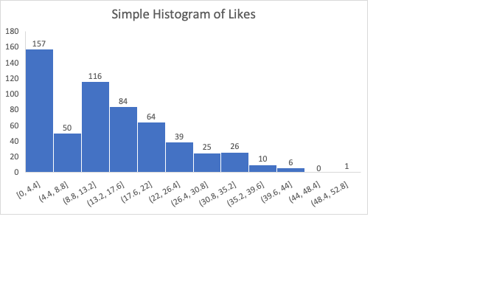

***Fig 1.0: Distribution of Likes***

The histogram above shows the distribution of likes. Likes variables has a right skewed distribution as most of the observation are located on the left side of the distribution. A right skewed distribution implies that products with few likes were recorded as the majority and only a few products with most likes was recorded.

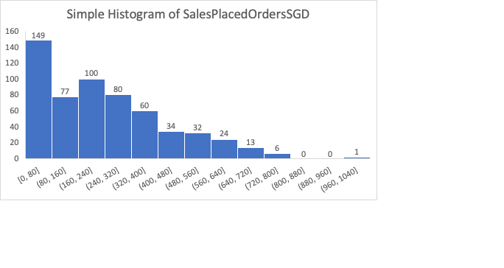

***Fig 1.1: Distribution of Sales Placed Orders***

The distribution of placed orders had also a right skewed distribution. 0 to 320 orders were recorded as the highest number of ordered items while only a few orders of 640 and above was recorded.

## 4.3: Inferential Statistics

Inferential statistics is a branch of statistics that deals with making business insights from a sample dataset. The datasets used in this research studies represents samples taken from a large database of products, customers at [modu.singapore](http://shopee.com/modu.singapore), an e-commerce marketplace. Inferential statistics was used to make inference to generalise to the entire population. Scatter plots are essential tools for identifying relationship among variables in a sample dataset. Any insights obtained from these sample datasets, was therefore generalised to the entire online shopping community. Establishing the impact of Covid-19 on consumer behaviour based on online shopping, data on products sales, product orders, page views, page likes was analysed, and time factor put in consideration.

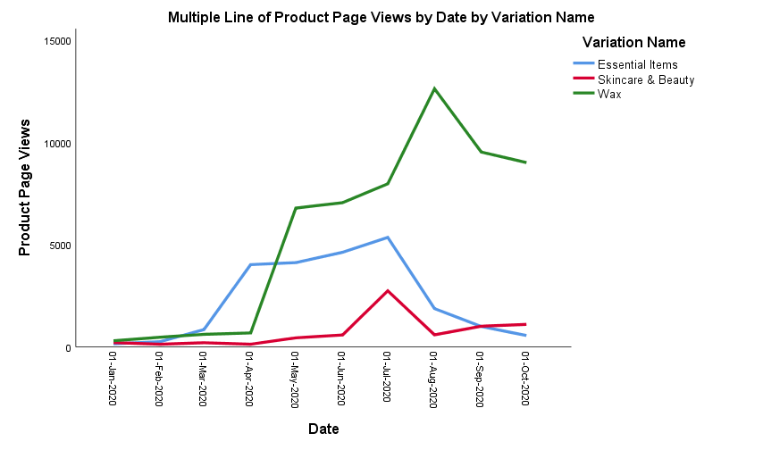

***Fig 1.2: Distribution of Pages View Over Time***

The figure above shows products page view for three different items - Wax, Essential items and Skincare and Beauty. From Jan 2020 to March 2020, the recorded number of page views were low, less than 200 for the three products categories. From March to April 2020 all the way to Oct 2020, a steep increase in page product views was recorded for the three products. The page views were above 200 for skin care and beauty, above 400 for essential items and above 500 for wax. The period of Jan 2020 to March 2020 can be regarded as the period before the pandemic and the period from March to October is the pandemic period. This visualisation gives insights that there was a lot of activities during Covid-19 period as compared to period before Covid-19.

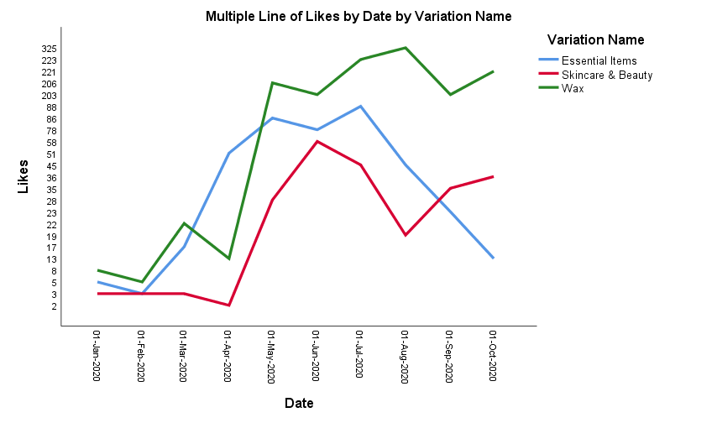

***Fig 1.3: Distribution of Products Likes with Time***

During the Covid-19 period, a steep increase can be noticed on the chart. A clear indication that most of shopping activities were taking place online. This observation can conclude that the pandemic made most of the customers engage in online shopping and online searches of products. Although a slight increase is evident in the periods of January to March 2020, it is in comparative to the period March to August 2020.

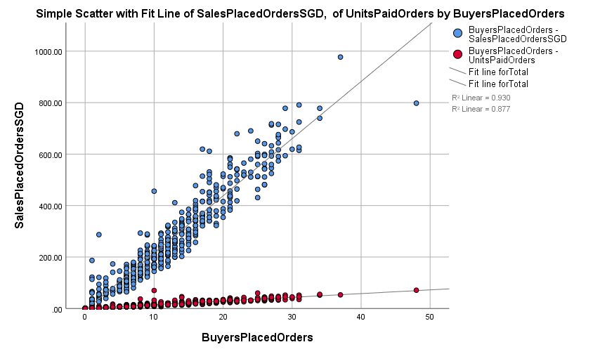

***Fig 1.4: Relationship between Buyers Placed Orders and Sales Placed Orders***

The relationship between placed orders and sales orders was identified as linear as shown by the scatter plot data points that form a straight line.

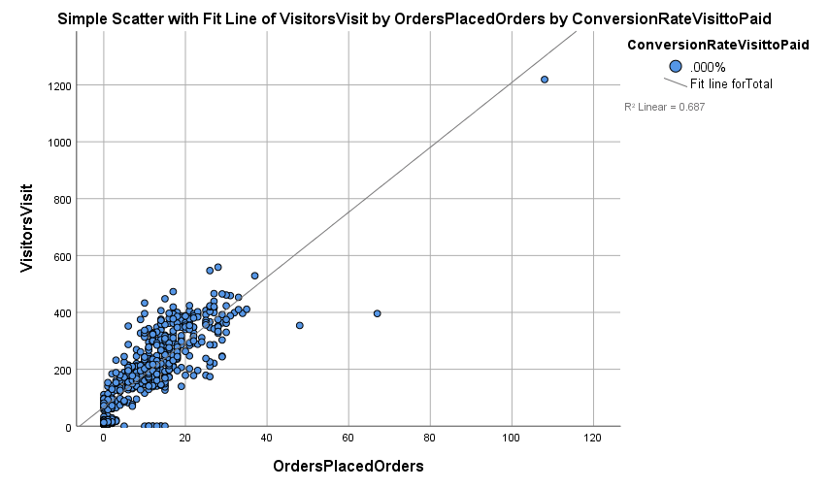

***Fig 1.5: Relationship between Visitors Visit and Placed Orders***

In Fig 1.5, the relationship between placed orders and visitors visit was also identified as linear. The scatter plot shows a possible liner retaliation of the data points.

## 4.4: Model Building

A regression model was fitted to investigate the impact of Covid-19 on consumer behaviour based on online shopping. Regression analysis is used to model data believed to have a linear relationship. The scatter plot generated shows that the variables in the data, products ordered, sales, visits, likes have a liner relationship. To quantify the impact of Covid-19 on consumer behaviour, the liner regression model was fitted. Multiple liner regression was applied since the explanatory variables were more than 2.

***Table 1.2: ANOVA Test***

The ANOVA test in multiple liner regression model is used to investigate the overall model significance. The F statistic score test significance of the model as alpha level 0.05. The model F score was computed as 894.263 with a p value of 0.000. This implies that the multiple linear regression fitted was statistically significant. The model shows squared error due to residual of 105111.479 and mean square error due regression was 93997319.003.

***Table 1.3: Multiple Linear Regression Model***

The model R squared score was computed calculated as .990 and the adjusted R squared score was .989. This implies that about 98.9% of the variance in sales was accounted by the explanatory variables used in the regression model.

***Table 1.4: Model Coefficients***

The model coefficients show the expected change in dependent variable on a unit change in independent variables. The model constant was computed as 32.662, with a standard error of 82.018, a t test statistic score of 0.788 and a p value of 0.038. the coefficient for paid orders was 3.168, with a standard error of 2.839, a t test statistic score of -1.996 and a p value of 0.056. The coefficient of buyers paid orders was 23.835, with a standard error of 3.563 and a t test statistic of 6.689 and a p value of 0.00. the product page views had a coefficient of .028 with a standard error of .043 and a t test score of .637 and a p value of .529. A comprehensive study of the model fitted showed that the Covid-19 had positive impact on online shopping and consumer behaviour. This is supported by the positive coefficient of the regression model. Additionally, an increase in sales, product vies, product likes was identified during the Covid-19 period. Further insights are conveyed that during the Covid-19 period most of the consumer engaged in online shopping. The model indicated that a unit increase in paid orders would increase sales by 32.66 units.

A unit increase in buyer paid orders would increase sales paid orders by 3.168 units. A unit increase in product page view would increase sales paid orders by .028 units.

## 4.5: Results Discussion

A shift in consumer behaviour was identified and ascertained in the Covid-19 period. Majority of consumers and customers used to shop in shopping malls and other physical shopping places. As Covid-19 hit, shopping and other transaction was transferred online, and this resulted to a hike in online shopping activities. The results obtained in this study shows that the Covid-19 pandemic impacted consumer behaviour heavily.The descriptive analysis conducted shows a linear prelateship between between placed orders and visitors visit, placed orders and sales orders. The association was positive, implying that an increase in other component would result to an increase in the other. The descriptive statistic showed that the mean for buyers placed orders was computed as 11.18 with a standard deviation of 9.458 and a variance of 89.445. the maximum and minimum scores were computed as 106 and 0. The skewness score was 2.460. The average unit placed orders was 16.97 with a standard deviation of 14.179 and a variance of 201.046. The maximum and minimum unit placed orders was computed as 124 and 0. Inferential statistic was used to obtain insight from sample data and make generalization on the entire population. The significance and performance of a multiple liner regression model is investigated using the F statistic score, the adjusted R squared score and the t test scores. The fitted multiple liner regression model was identified as statistically significant since the p value associated with the F statistic was less than 0.05. This supported that the model was statistically significant. The t test gives the significance of the coefficients. All the coefficients were statistically significant apart from the page views that had a p value >0.05.

## 4.6: Conclusion and Recommendation

Covid-19 had a statistically significant impact on consumer behaviour. This has been supported by descriptive statistics, inferential statistics, and the fitted model. Moreover, the impact was positive since all the coefficients of the regression model were positive. The line charts clearly indicated a hike in product sales, product page views, product lines during the Covid-19 period. Several contributions are drawn from the research for both practitioners and researchers in market and retail. To survive the Covid-19 restriction effects, marketers and retailers must learn on better strategies. Suppliers and retailers should learn how to use the knowledge on consumer pattern changes and their needs. They should put into consideration the reasons behind consumers selecting new shopping items and how fear affects them. Retailer and marketers should use different approaches especially during purchase decision making. Retailing process and marketing communication should minimize risks associated with the shopping process through addressing their fears. That calls for after sales services like money back guarantees be offered to minimize uncertainties during online shopping and reduce security risks. This study shows the priority items among consumers during the COVID-19 pandemic and how customer purchasing behaviour was influenced by the changing needs. The study concluded that during the pandemic customers were more interested in the basic needs. The research also showed the impact of Fear Appel Theory by separating it economic fear and health fear. This strategy helped in giving an in-depth of effects of selected fears.

## 4.7: Study Limitations

First, the research emphasised on consumer behaviour during the pandemic in Singapore. Also, the research design came from known sources which secondary data was utilised. Besides, the data was derived using the online random sampling in the mentioned country. Recommendation for future research is that the question asked by Sheth (2020, 280) needs a follow up “Will consumers permanently change their consumption habits due to lockdown and social distancing or will they go back to the old habits once the global crisis is over?”.

**(8810 words)**

# References

Abdul, A., & Mia, A. (2020). The economic impact of the COVID-19 outbreak on developing Asia. https://www.adb. org/sites/default/files/publication/571536/adb-brief-128- economic-impact-covid19-developing-asia. Pdf

ALESSA, A. A., ALOTAIBIE, T. M., ELMOEZ, Z., & ALHAMAD, H. E. (2021). Impact of COVID-19 on Entrepreneurship and Consumer Behaviour: A Case Study in Saudi Arabia. The Journal of Asian Finance, Economics and Business, 8(5), 201-210.

Arora, N., Robinson, K., Charm, T., Ortega, M., Staack, Y., Whitehead, S., & Yamakawa, N. (2020). Consumer sentiment and behaviour continue to reflect the uncertainty of the COVID-19 crisis. McKinsey & Company, July.

Edwards, J. O. H. N. (2019). What is predictive analytics? Transforming data into future insights. CIO Australia.

Hasanat, M. W., Hoque, A., Shikha, F. A., Anwar, M., Hamid, A. B. A., & Tat, H. H. (2020). The impact of coronavirus (COVID-19) on e-business in Malaysia. Asian Journal of Multidisciplinary Studies, 3(1), 85–90.

Kim, R. Y. (2020). The impact of COVID-19 on consumers: Preparing for digital sales. IEEE Engineering Management Review, 48(3), 212-218.

Larios-Gómez, E., Fischer, L., Peñalosa, M., & Ortega-Vivanco, M. (2021). Purchase behaviour in COVID-19: A cross study in Mexico, Colombia, and Ecuador. Heliyon, 7(3), e06468.

Mehta, S., Saxena, T., & Purohit, N. (2020). The new consumer behaviour paradigm amid COVID-19: Permanent or transient?. Journal of Health Management, 22(2), 291-301.

Meyer, S. (2020). Understanding the COVID-19 effect on online shopping behaviour. The BigCommerce Blog.

Puttaiah, M., Raverkar, A., & Avramakis, E. (2020). All change: how COVID-19 is transforming consumer behaviour. Swiss Re Institute. https://www.swissre.com/institute/research/topics-andrisk-dialogues/health-and-longevity/Covid-19-and-consumerbehaviour.html

Safara, F. (2020). A computational model to predict consumer behaviour during COVID-19 pandemic. Computational Economics, 1-14.

Sheth, J. (2020). Impact of Covid-19 on consumer behaviour: Will the old habits return or die?. Journal of business research, 117, 280-283.

Svajdova, L. (2021). Consumer Behaviour during Pandemic of COVID-19. Journal of International Business Research and Marketing, 6(3), 34-37.

Zhang, C., Jiang, J., Jin, H., & Chen, T. (2021). The Impact of COVID-19 on Consumers’ Psychological Behaviour Based on Data Mining for Online User Comments in the Catering Industry in China. *International Journal of Environmental Research and Public Health*, *18*(8), 4178.

Eger, L., Komárková, L., Egerová, D., & Mičík, M. (2021). The effect of COVID-19 on consumer shopping behaviour: Generational cohort perspective. Journal of Retailing and Consumer Services, 61, 102542.

Grashuis, J., Skevas, T., & Segovia, M. S. (2020). Grocery shopping preferences during the COVID-19 pandemic. Sustainability, 12(13), 5369.

Hinton, P., McMurray, I., & Brownlow, C. (2014). SPSS explained. Routledge.

Pallant, J. (2020). SPSS survival manual: A step by step guide to data analysis using IBM SPSS. Routledge.

Safara, F. (2020). A computational model to predict consumer behaviour during COVID-19 pandemic. *Computational Economics*, 1-14.

# Appendix

Relationship between Product page views and sales paid orders based on Items

Relationship between Items visited and Units added to cart based on Items paid

Relationship between Conversion rate and placed sales orders

